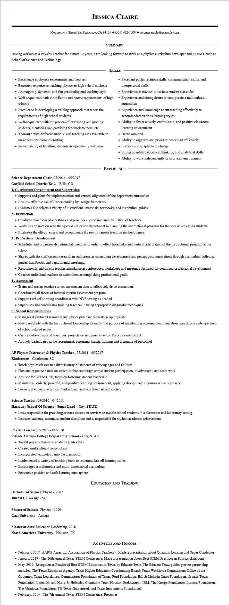
JESSICA CLAIRE
Montgomery Street, San Francisco, CA 94105 ♦ (555) 432-1000 resumesample@example.com
SUMMARY
Having worked as a Physics Teacher for almost 12 years, I am looking forward to work as a physics curriculum developer and STEM Coach at School of Science and Technology.
• Excellence in physics experiments and theories.
• Extensive experience teaching physics to high school students
• An outgoing, dynamic, and fun personality and teaching style
SKILLS
• Well-acquainted with the syllabus and course requirements of high schools
• Excellence in developing a training approach that meets the requirements of high school students
• Well-acquainted with the process of evaluating and grading students, mentoring and providing feedback to them, etc.
• Thorough with different audio-visual teaching aids available to make sessions more interesting
• Proven ability of handling students independently with ease
Science Department Chair, 07/2014 - 05/2017 Garfield School District Re-2 - Rifle, CO
1. Curriculum Development and Supervision
• Excellent public relations skills, communication skills, and interpersonal skills
• Experience as advisor to various student-run clubs
• Experience and strong desire to incorporate a multicultural curriculum
• Experience and knowledge about teaching effectively to accommodate various learning styles
• Ability to foster a lively, enthusiastic, and positive classroom learning environment
• Detail oriented
• Ability to organize and prioritize workload effectively
• Flexible and adaptable to change
• Strong quantitative, critical thinking, and analytical skills • Ability to work independently or in a team environment
EXPERIENCE
• Supports and plans for implementation and vertical alignment of the department curriculum
• Ensures effective use of Understanding by Design framework
• Evaluates and selects a variety of instructional materials, textbooks, and curriculum guides
2. Instruction
• Conducts classroom observations and provides supervision and evaluation of teachers
• Works in conjunction with the Special Education department in planning the instructional program for the special education students.
• Evaluates the effectiveness, and recommends the use of various teaching methodologies.
3. Professional Development
• Schedules and organizes departmental meetings in order to effect horizontal and vertical articulation of the instructional program at our schoo
• Shares with the staff current research in such areas as curriculum development and pedagogical innovations through curriculum bulletins, guides, handbooks and departmental meetings.
• Recommends and directs teacher attendance at conferences, workshops and meetings designed for continued professional development
• Coaches individual teachers to assist them accomplishing professional goals.
4. Assessment
• Trains and assists teachers to use assessment data to effectively drive instruction.
• Coordinates all facets of internal interim assessment program.
• Supports school's testing coordinator with NYS testing as needed.
• Supervises and coordinates training teachers in using appropriate diagnostic techniques.
5. School Responsibilities
• Manages department resources and places purchase requests as appropriate.
• Meets regularly with the Instructional Leadership Team for the purpose of maintaining ongoing communication regarding a wide spectrum of school related issues.
• Carries out such special functions, projects or assignments as the Directors may direct
• Actively participates in the recruitment, screening, hiring, training and assigning of personnel
AP Physics Instructor & Physics Teacher, 07/2011 - 05/2017
Kindercare - Charleston, SC
• Teach physics classes to a diverse array of students of varying ages and abilities
• Plan and organize hands-on activities that encourage active student participation, involvement, and team work
• Advisor for STEM Club, focus on fostering student leadership
• Maintain an orderly, peaceful, and positive learning environment, applying disciplinary measures when necessary
• Foster and encourage critical thinking and analysis about art and society
Science Teacher, 09/2010 - 04/2011
Harmony School Of Science - Sugar Land - City, STATE
• I was responsible for providing science education services to middle school students in a classroom and laboratory setting.
• Instructs students, maintains student discipline and is responsible for student academic achievement.
Physics Teacher, 07/2005 - 05/2010
Private Maltepe College Preparatory School - City, STATE
• Taught physics classes to students grades 9-12
• Created multicultural lesson plans
• Incorporated technology into the classroom
• Implemented a variety of teaching tools to accommodate all learning styles
• Encouraged a multimedia and multi-dimensional curriculum
• Fostered a positive and safe learning atmosphere
Bachelor of Science: Physics, 2007
100. Yil University - Van
Master of Science: Physics, 2010
Gazi University - Ankara
Master of Arts: Education Leadership, 2018
North American University - Houston, TX
EDUCATION AND TRAINING
ACTIVITIES AND HONORS
• February, 2017- AAPT(American Association of Physics Teachers): Made a presentation about Quantum Locking and Super Conductor ⚫ January, 2017 - The 10th Annual Texas STEM Conference; Made a presentation about Best STEM Practices in Physics classroom
• May, 2016- Recognize as Finalist of Best STEM Educators in Texas by Educate Texas (The Educate Texas public-private partnership includes: The Texas Education Agency; Texas Higher Education Coordinating Board; Texas Workforce Commission; Office of the Governor, Texas Legislature; Communities Foundation of Texas; Ford Foundation; Bill & Melinda Gates Foundation; Greater Texas Foundation; Leona M. and Harry B. Helmsley Charitable Trust; Houston Endowment; IBM; The Kresge Foundation; Lumina Foundation; The Meadows Foundation; TG Texas Guaranteed; and Texas Instruments Foundation).
• February, 2014 - The 7th Annual Texas STEM Conference; Presenter

